

Kashaf Hussain

O

Hvuualsj

**Lab Automation**

*Documentation*

TEAM MEMBERS

*Ayesha Faculty: Sir simon*

*Rida Batch: 2109d01*

*Ifra*

*Sajith*

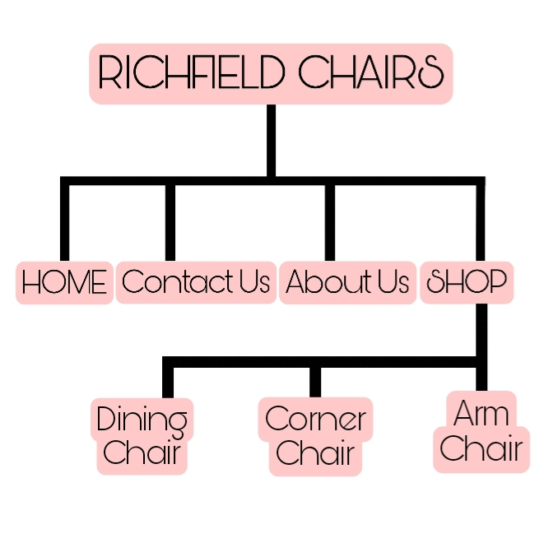

***TABLE OF CONTENT***

*CERTIFICATE OF COMPLETION --------------------------------------------------------- 4*

*ACKNOWLEDGEMENT ---------------------------------------------------------------------- 4*

*PROBLEM DEFINATIONS ------------------------------------------------------------------- 5*

*CUSTOMER REQUIREMENTS SPECIFICATIONS----------------------------------- 6*

*PROJECT PLAN ------------------------------------------------------------------------------- 7*

*HRDWARE/SOFTWARE REQUIREMENTS ------------------------------------------- 8*

*PROJECT INFORMATION -------------------------------------------------------------- 9-10*

* *TASKSHEET --------------------------------------------------------------------------------------------9*
* *VALIDATIONS ---------------------------------------------------------------------------------------- 10*
* *SUBMISSIONS --------------------------------------------------------------------------------------- 10*

*SNAPSHOT -------------------------------------------------------------------------------- 11-16*

***CERTIFICATE OF COMPLETION***

*This is to certify:*

*AYESHA ABBAS (Student1336644)*

*IFRA HASHIM (Student1336159)*

*RIDA KAMRAN(Student 1336178)*

*SAJITH SUHOOD(Student 1336159)*

*Student of* ***APTECH GARDEN CENTER,*** *batch* ***2101D01:***

***TITLE: “****RICHFIELD-CHAIR****”***

***Project submitted:*** *24-JANUARY-2022*

***ACKNOWLEDGEMENT***

*I would like to acknowledge all those who have given moral support and helped in making the project a success.*

*I wish to express my gratitude to “E-Project” Team of Head Office who guided and helped me. Also, I would like to express my gratitude to all the faculty members of my center for not only providing me opportunity to work with them on this project, but also for their support and encouragement throughout the process.*

# *I also express my sincere gratitude to e-Project Team from aptech Head Office and my project guide at the organization for his valuable guidance and support for completion of this project.*

# *Final, I would like to offer many thanks to all my colleagues for their valuable suggestions and constructive feedback.*

**PROBLEM STATEMENT**

**Richfield Chairs is an organization selling Chairs. They produce various chairs ofdifferent types suiting every requirement and into various sizes, starting from kids to office to home and etc. You are supposed to create a website for them with the below mentioned requirement specifications. The website is to be developed for the Windows Platform using HTML5, JavaScript and Geolocation. The site should work well in all leading browsers including Chrome, IE, Firefox etc.**

**Requirment Specification:**

**The Web site is to be created based on the following requirements.**

**1) The Home Page should be created making use of Sections with a suitable**

**logo, the header section can be added which will show images chairs.**

**2) The site must contain the links to navigate through any category for the**

**information.**

**3) The site should display a menu which will contain the options for brief**

**introduction about the various furniture’s available, location of the shop and**

**any other information if required.**

**4) The information should be categorized according to the brand names of the**

**chairs like if a User wants to see only “LEO” chairs or any other companies**

**chairs then he/she can click on a Link/button/menu etc and can see only that**

**Brand chairs.**

**5) When a user selects any particular brand, a list of chairs for that brand will be**

**displayed**

**6) A brief summary of features of the chairs should be displayed on the Web**

**Page along with the picture but detailed Features should be stored in**

**Individual Word documents which can be downloaded or viewed by the User**

**who wishes to see the same.**

**7) The user should also be able to compare the various chairs of different as well**

**as similar brands.**

**8) There should be a “Contact Us” page which will have the Address of the**

**Company which should be displayed using Geo Location API (eg. Google Maps)**

**and the email address which when clicked will invoke the local mail client**

**from where they can send an email.**

**Customer Requirements Specification**

* The details are needed to be captured based on the type of the testing and as well based on the product.
* The status of the testing and as well the detailed remarks is also needed to be captured.
* An advanced search option is needed to be included so that one can fetch the details of the testing at an ease.

***HARDWARE/SOFTWARE REQUIREMENTS***

**Hardware:**

**Hardware**

• A minimum computer system that will help you access all the tools in the

courses is a Pentium 166 or better

• 64 Megabytes of RAM or better

* **Software:**

• Notepad/HTML editor

• Dreamweaver

• IE 5.0/ Netscape 6.0

|  |  |  |  |  |
| --- | --- | --- | --- | --- |
| # | *TASK* | *DONE BY* | *DAYS* | *STATUS* |
| 1 | Contact Us | Rida | 7 | Completed |
| 2 | Sign-Up | Rida | 7 | Completed |
| 3 | Home, About-us and Shop | Sajith | 7 | Completed |
| 4 | Documentation | Sajith | 1 | Completed |
| 5 | Design and Data collection | Sajith | 4 | Completed |

***PROJECT INFORMATION***

**Tasksheet:**

**Submissions:**

* **Submissions:**

|  |  |  |  |
| --- | --- | --- | --- |
| **PARTICULARS** | **YES** | **NO** | **COMMENTS** |
| Do all the pages open | **✔** | **-** | **-** |
| Are all hyperlinks working? | **✔** | **-** | **-** |
| Are the web page contents devoid of spelling mistakes | **✔** | **-** | **-** |
| Are the page color as per | **✔** | **-** | **-** |

***SNAPSHOTS***

* **HOME**

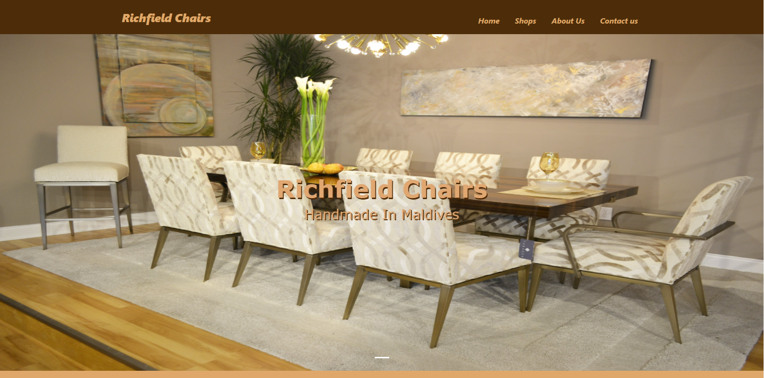

* **ABOUT US**

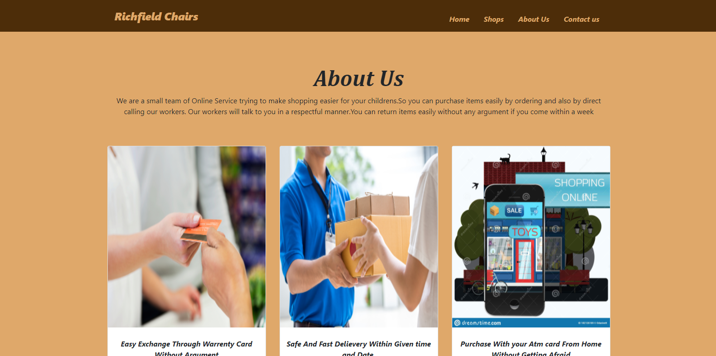

* **CONTACT US**

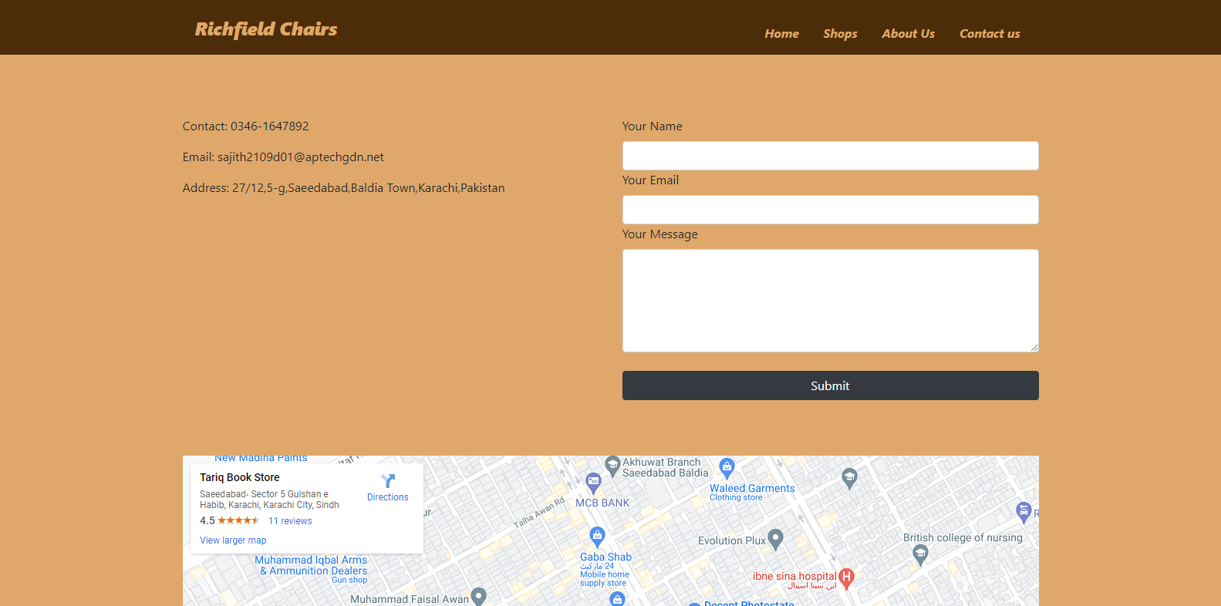

* **SHOP**

